Monaro Folk Society – Set in Their Ways
Annual Report 2022/23

SITW had a good year this year with dancing continuing on Monday nights and a few external events.
The aim of SITW’s is to provide advanced dancing opportunities in Irish Set Dancing (ISD) and to promote MFS and ISD through displaying and teaching at festivals and events. SITW was able to do this through being accepted as a performance group into the National Folk Festival (NFF) and doing a display at the National Gallery of Australia. The performances were a great success and have resulted in new members attending the Wednesday ISD classes.
The groups finances are summarised below:
Description | Income | Expenditure | Profit / Loss
Financial Year Total | $ 3030 | $ 2,590* | $440
*$255 adjust for carry over from FY22/23

A total profit of $440 (reported) or $695 total for the financial year was achieved by the group. The income is due to attendance intake of $10 per person. The expenditure is the Hall hire fees. Expenditure is less than the approved budget resulting in a higher than budgeted profit.
Thanks to Paul and Leslie Carr, James and Sally Garner, Christine Briton and all the members of SITW.
We look forward to sharing the joy of Irish Set Dancing together this coming year….

Prepared by: Peter Stringfellow (SITW Admin Coordinator) July 2023

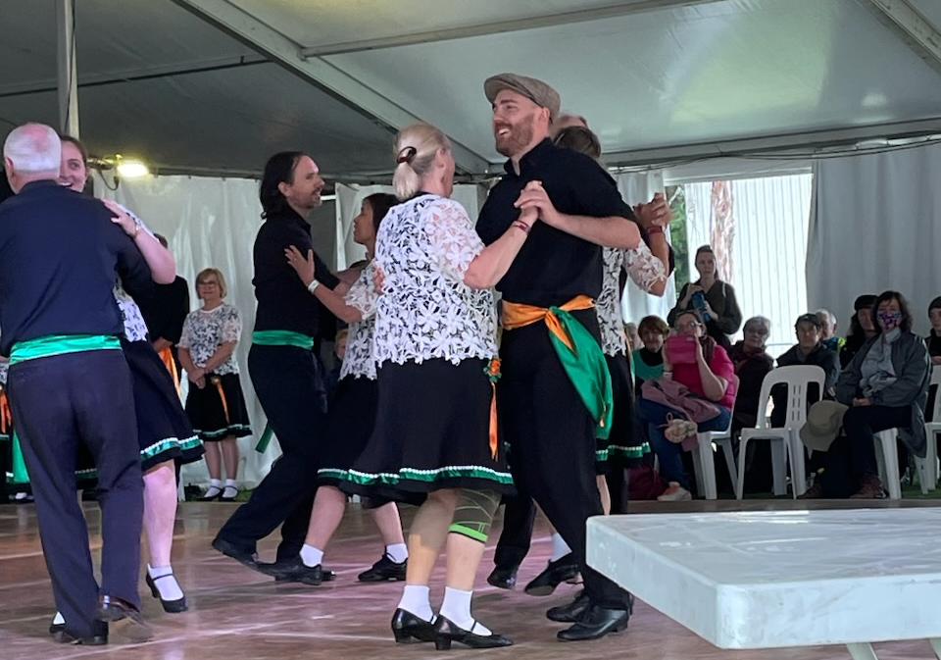
Figure 1 - SITW @ the NFF

